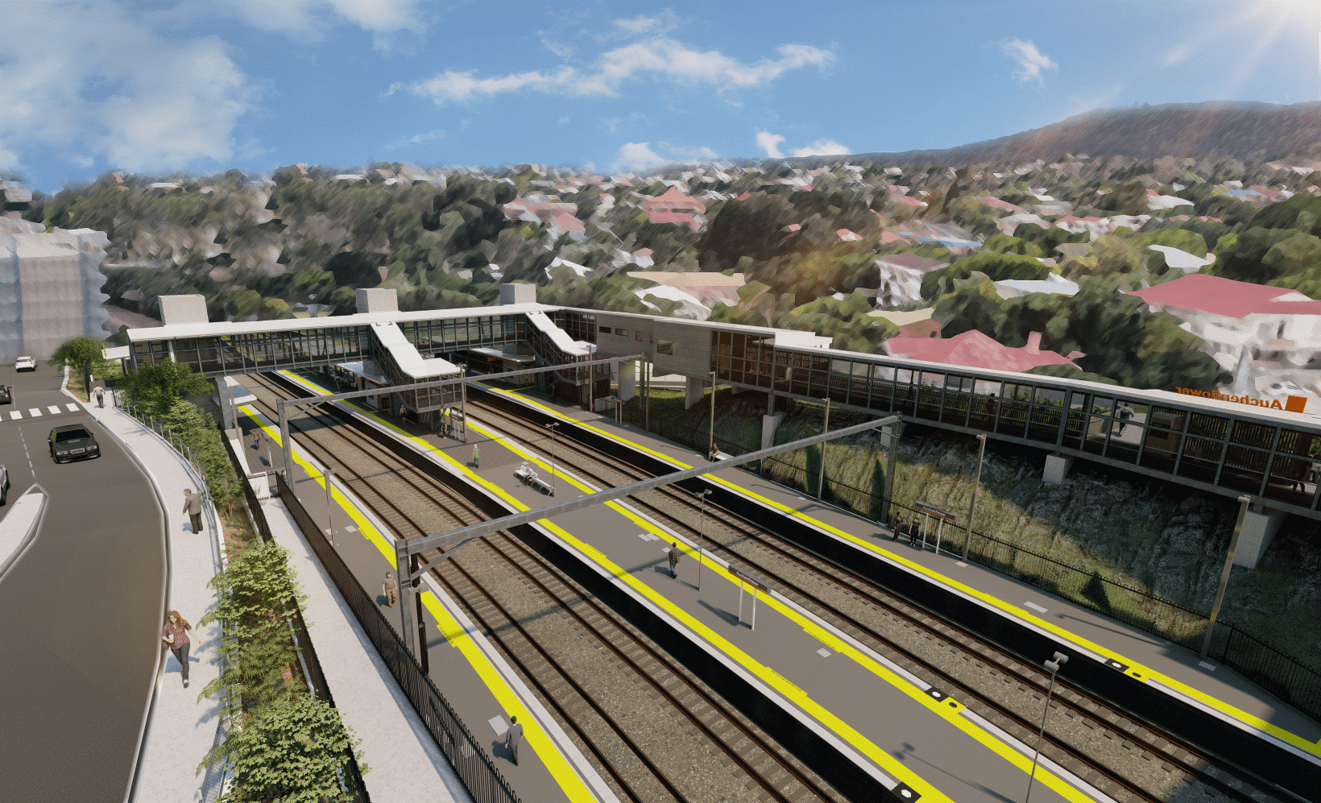

**Auchenflower station accessibility upgrade**

**WORKS NOTICE**

**Night and after hours works**

**November 2022**

As part of the Auchenflower station accessibility upgrade, Queensland Rail will undertake concrete pours overnight on **Wednesday 2 and Thursday 3 November (each night between 6pm and 6am the next morning)**.

In addition, around-the-clock activities will be undertaken **from 6pm Friday 4 until 6am Monday 7 November** during the weekend’s scheduled track closure.

For safety, these works have been scheduled at times when rail traffic is reduced and during a scheduled weekend track closure when buses will be replacing trains.

During the weekend track closure, the station footbridge and lifts will be closed for works. Cross-corridor pedestrian access will be maintained via the new footbridge (Lang Parade, at Chasely Street) – please follow directional signage and take care around the work zones.

To support site access and construction activity, localised lane closures and traffic management may be in operation at times throughout the month. Motorists are requested to follow the instructions of the traffic controllers and drive to the changed conditions.

Residents near the station may experience noise associated with construction activity and truck movements. Every effort will be made to minimise disruption and we thank you for your patience during these important works.

# Overview of works (weather and construction conditions permitting)

Queensland Rail Limited ABN 71 132 181 090

|  |  |  |
| --- | --- | --- |
| **Location** | **Dates and hours of work** | **Type of work** |
| Auchenflower station, carpark and rail corridor  Station footbridge/lifts – closed  New footbridge (at Chasely Street) – open  Surrounding local streets (traffic management) | *Night works – concrete pours*  **6pm to 6am** the next dayon:   * **Wednesday 2 November** * **Thursday 3 November**   (over two nights)  *Continuous weekend works (during track closure)*   * **6pm Friday 4 to 6am Monday 7 November**   (around-the-clock works) | Station upgrade activities involving:   * concrete pumping activities * station entry and footpath works * platform works including paving and asphalting * operation of machinery and heavy equipment * use of hand-held tools and powered equipment * delivery and unloading of materials by truck * movement of vehicles and machinery with flashing lights and reversing beepers * portable lighting towers in use at night * lane closures and traffic management if/as required. |

The Auchenflower station accessibility upgrade is part of the State Government’s ongoing investment of more than $500 million to upgrade stations across the South East Queensland network, making them accessible for all customers.

For more information, please contact the project’s community team on free call **1800 722 203** or email [**stationsupgrade@qr.com.au**](mailto:stationsupgrade@qr.com.au)

Sign up for electronic notifications at **queenslandrail.com.au/EmailNotification**