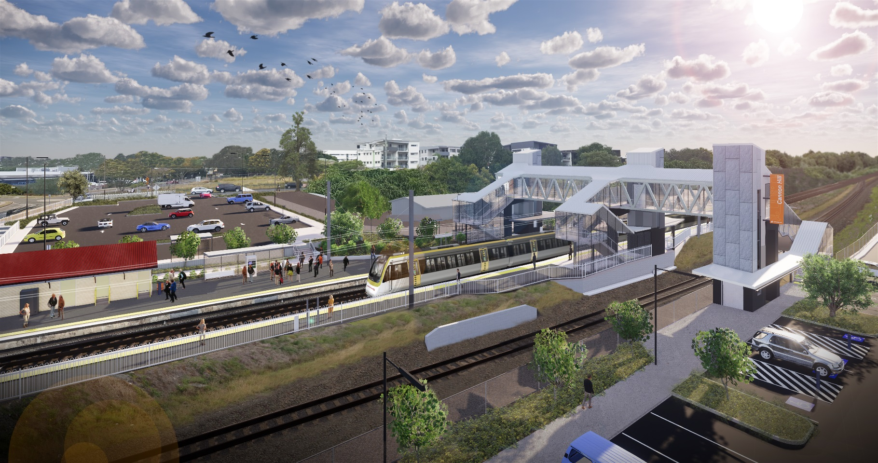

Concept design – subject to change

**Cannon Hill station accessibility upgrade**

**Queensland Rail is striving to become a modern, customer-focused rail service and is investing $300 million to upgrade stations, making them accessible for all customers.**

As part of the Station Accessibility Upgrade Program, Queensland Rail is making improvements to Cannon Hill station.

These improvements include:

* a new pedestrian footbridge with lift access
* raised section of platform at assisted boarding points
* upgraded hearing augmentation loop and tactile platform surfaces
* upgraded security cameras and station lighting around the core zone
* new wayfinding and platform signage around the core zone.

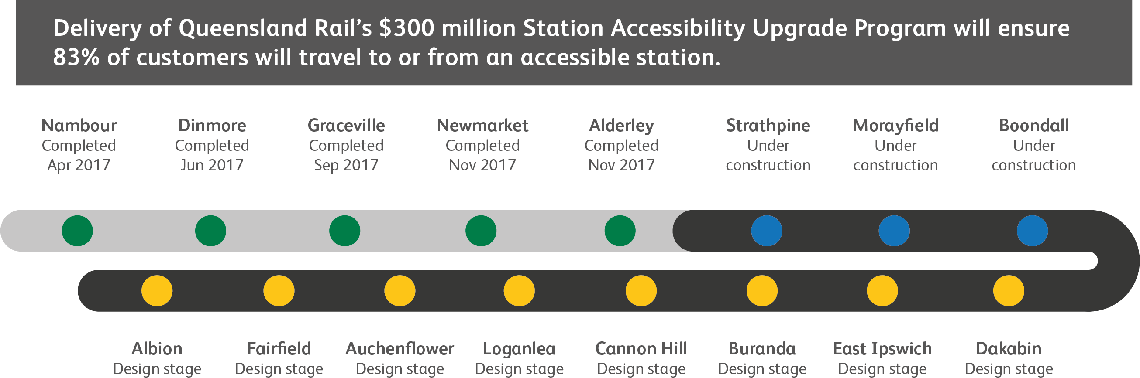

**PROJECT UPDATE – MARCH 2019**

The concept design is now available and we are seeking your input.

We are committed to keeping customers, local residents and community groups informed as the project progresses.

The next step will be to call for tenders for a contractor to undertake detailed design and construction for the project.

For further information about the Cannon Hill station accessibility upgrade or to provide feedback:

Phone: **1800 722 203** (free call)

Email: **stationsupgrade@qr.com.au**

Post: **GPO Box 1429 Brisbane QLD 4000**

Website: **queenslandrail.com.au**

