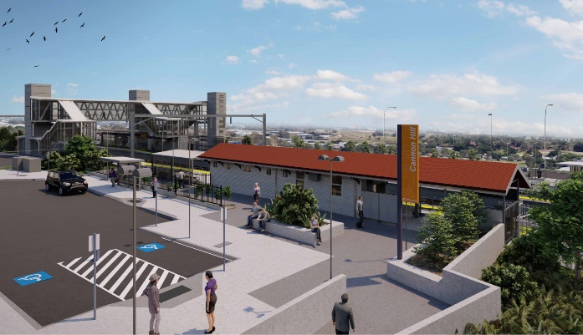

**Cannon Hill station accessibility upgrade**

0

**WORKS NOTICE**

**Weekend and after hours works (during track closure)**

**5am Saturday 18 to 8pm Sunday 19 June 2022**

Queensland Rail will undertake weekend and after hours works, associated with the Cannon Hill station accessibility upgrade from **5am Saturday 18 until 8pm Sunday 19 June 2022** (weather and construction conditions permitting).

Activities include platform and shelter works, concreting, fencing installation and landscaping. For safety, these works have been planned during a scheduled track closure when there is no rail traffic and the overhead power is switched off.

Parts of the station’s carparks will be unavailable from 6am Saturday 18 until 7pm Sunday 19 June and the Barrack Road level crossing will be closed to traffic during works. Traffic management will be in operation with a traffic diversion around the works. Motorists are requested to follow the instruction of the traffic controllers and drive to the changed traffic conditions.

The station’s footbridge (and lifts) will be available for cross-corridor pedestrian access.

Residents near the station may experience some noise associated with construction activity and the operation of cranes, trucks and equipment around the work zone. Every effort will be made to minimise disruption and we thank you for your patience during these important works.

# Overview of works

Queensland Rail Limited ABN 71 132 181 090

|  |  |  |
| --- | --- | --- |
| **Location** | **Dates and hours of work** | **Type of work** |
| Cannon Hill station precinct and rail corridor  Station carparks (partially closed)  Barrack Road level crossing – closed to traffic  Footbridge/lifts – open | **5am Saturday 18 to 8pm Sunday 19 June 2022**  (around-the-clock works during track closure) | Associated station upgrade activities, involving:   * platform and shelter works * asphalting and concreting * fencing installation and landscaping * operation of trucks and machinery with flashing lights and reversing beepers * use of hand-held tools and powered equipment * movement of personnel and vehicles around the station precinct * portable lighting towers in use at night. |

The Cannon Hill station accessibility upgrade is part of the State Government’s ongoing investment of more than $500 million to upgrade stations across the South East Queensland network, making them accessible for all customers.

For more information, please contact the project’s community team on free call **1800 722 203** or email [**stationsupgrade@qr.com.au**](mailto:stationsupgrade@qr.com.au)

Sign up for electronic notifications at **queenslandrail.com.au/EmailNotification**