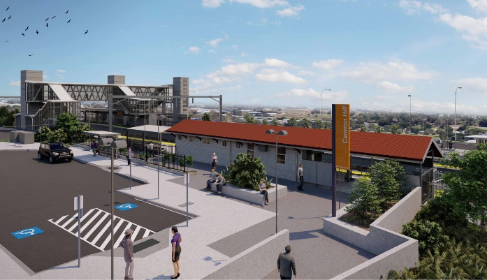

**Cannon Hill station accessibility upgrade**

**WORKS NOTICE**

**Night works – footbridge stair installation**

**Saturday 17 April 2021**

As part of the Cannon Hill station accessibility upgrade, Queensland Rail will install new footbridge stairs overnight on **Saturday 17 April 2021** (weather and construction conditions permitting).

For safety, these works have been scheduled when there is no rail traffic and the overhead power is switched off.

Residents near the station may experience some noise associated with construction activity and the operation of cranes, trucks and equipment around the work zone.

Every effort will be made to minimise disruption and we thank you for your patience while we build you a better Cannon Hill station.

# Overview of works

Queensland Rail Limited ABN 71 132 181 090

|  |  |  |
| --- | --- | --- |
| **Location** | **Dates and hours of work** | **Type of work** |
| Cannon Hill station precinct, including carparks and rail corridor | **6pm to 6am** the next day on:   * **Saturday 17 April**   (overnight works) | Installation of footbridge stairs (platform 1) involving:   * delivery of stair units by truck * operation of a large crane, elevated work platforms, trucks and machinery with flashing lights and reversing beepers * use of hand-held tools and powered equipment including ‘rattle guns’ to tighten stair bolts * movement of personnel and vehicles around the station precinct * portable lighting towers in use at night. |

The Cannon Hill station accessibility upgrade is part of the State Government’s ongoing investment of more than $500 million to upgrade stations across the South East Queensland network, making them accessible for all customers.

For more information, please contact the project’s community team on free call **1800 722 203** or email [**stationsupgrade@qr.com.au**](mailto:stationsupgrade@qr.com.au)



