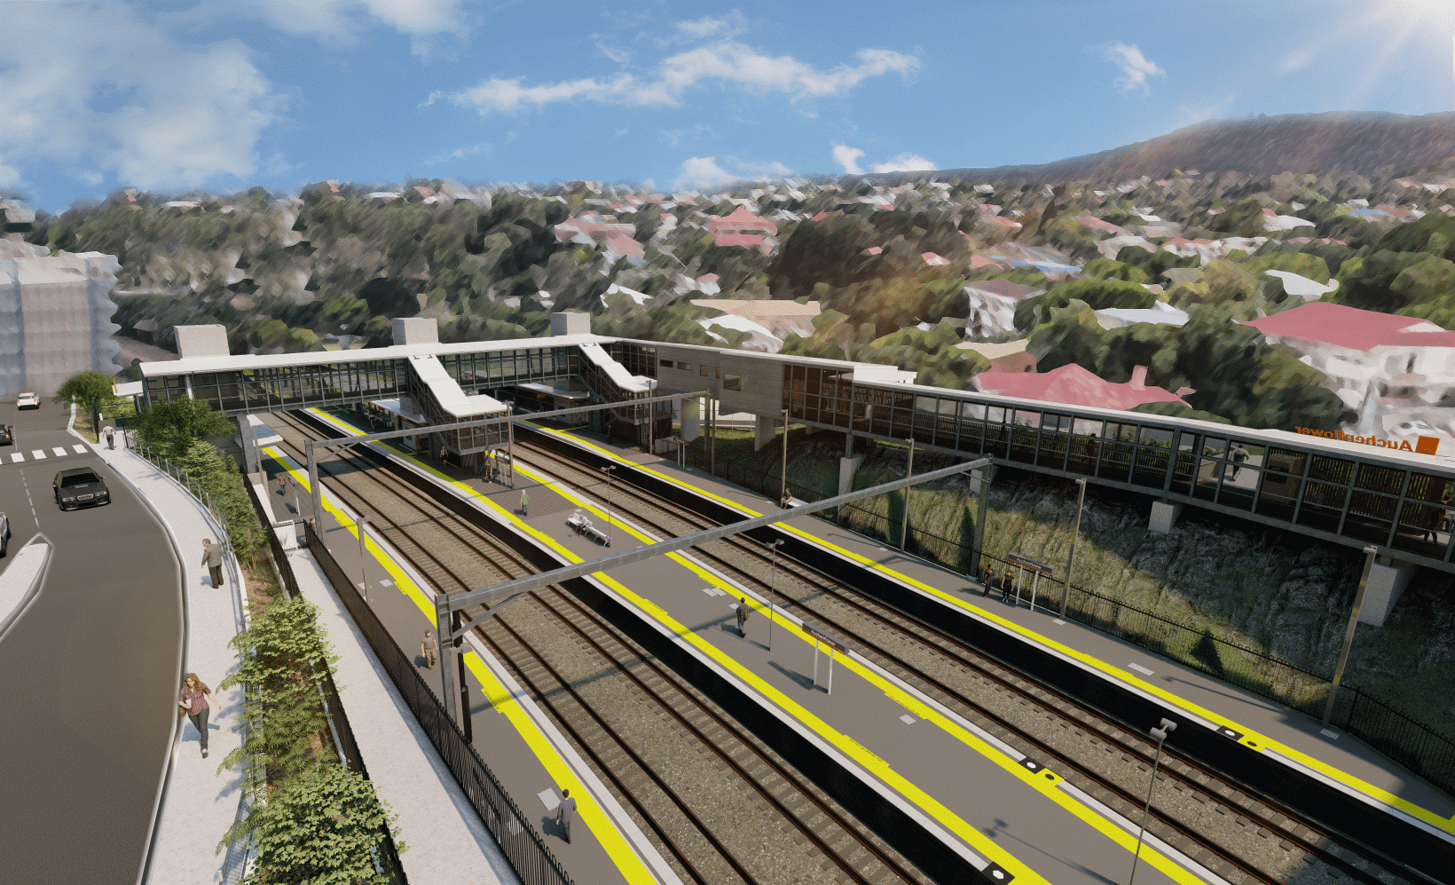

**Auchenflower station accessibility upgrade**

**WORKS NOTICE**

**Weekend works – platform activities**

**Saturday 11 and Sunday 12 February 2023, 6am to 6pm**

Queensland Rail will undertake weekend works on **Saturday 11 and Sunday 12 February** (**6am to 6pm** – day shifts only) as part of the completion of the Auchenflower station accessibility upgrade.

Activities will involve surface sealing and paver finishing works on the station platforms.

For safety, these works have been scheduled during a planned track closure when there are no trains operating. Sunday will be worked only if required.

Residents near the station may experience noise associated with the presence of personnel around the station precinct.

Every effort will be made to minimise disruption and we thank you for your understanding during these activities.

**Overview of works** (weather and construction conditions permitting)

Queensland Rail Limited ABN 71 132 181 090

|  |  |  |
| --- | --- | --- |
| **Location** | **Dates and hours of work** | **Type of work** |
| Auchenflower station precinct  (including platforms and carpark) | **6am to 6pm** on:   * **Saturday 11 February** * **Sunday 12 February** (if required)   (day shifts only) | Platform activities:   * paving repairs * surface sealing * use of hand held tools * presence of workers on platforms and throughout the station precinct * movement of project vehicles with reversing beepers. |

The Auchenflower station accessibility upgrade is part of the State Government’s ongoing investment of more than $500 million to upgrade stations across the South East Queensland network, making them accessible for all customers.

For more information, please contact the project’s community team on free call **1800 722 203** or email [**stationsupgrade@qr.com.au**](mailto:stationsupgrade@qr.com.au)

Sign up for electronic notifications at **queenslandrail.com.au/EmailNotification**