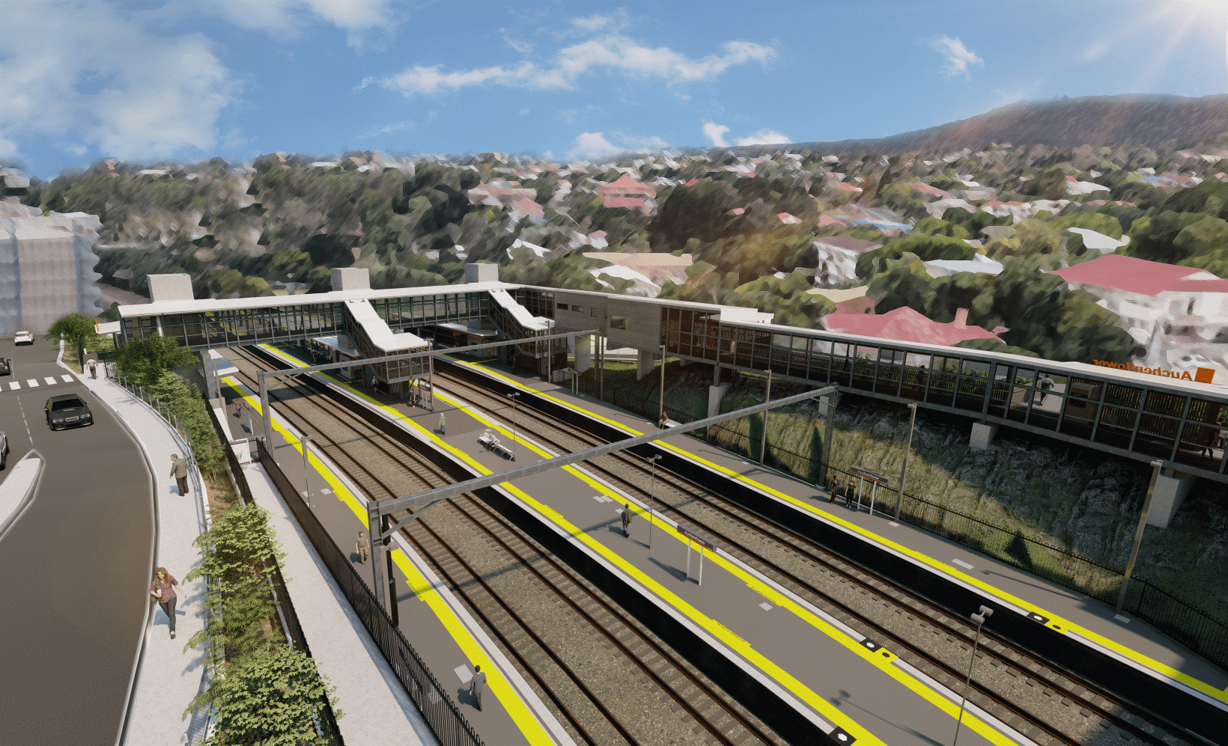

**Auchenflower station accessibility upgrade**

**WORKS NOTICE**

**Night works – temporary ticket office removal**

**1am Wednesday 12 October 2022**

As part of the Auchenflower station accessibility upgrade, Queensland Rail will remove the temporary ticket office from site **from approximately** **1am on Wednesday 12 October 2022**. Works are expected to take approximately one hour.

For safety, these works have been scheduled outside of timetabled rail services when there are fewer people around the station precincts.

During this time, cross-corridor pedestrian access will be via the station subway on lower Auchenflower Terrace.

Residents near the station may experience noise associated with the operation of a crane and truck movements. Every effort will be made to minimise disruption and we thank you for your patience during these important works.

# Overview of works (weather and construction conditions permitting)

Queensland Rail Limited ABN 71 132 181 090

|  |  |  |
| --- | --- | --- |
| **Location** | **Dates and hours of work** | **Type of work** |
| Auchenflower station and carpark  Auchenflower Terrace (corner Ridley Street) | **From 1am on Wednesday 12 October** for approximately one hour  (overnight works – Tuesday night/ Wednesday morning) | Removal of temporary ticket office:   * operation of crane * operation of machinery and heavy equipment * use of hand-held tools and powered equipment * movement of vehicles and machinery with flashing lights and reversing beepers * portable lighting towers in use at night * traffic management if/as required. |

The Auchenflower station accessibility upgrade is part of the State Government’s ongoing investment of more than $500 million to upgrade stations across the South East Queensland network, making them accessible for all customers.

For more information, please contact the project’s community team on free call **1800 722 203** or email [**stationsupgrade@qr.com.au**](mailto:stationsupgrade@qr.com.au)

Sign up for electronic notifications at **queenslandrail.com.au/EmailNotification**