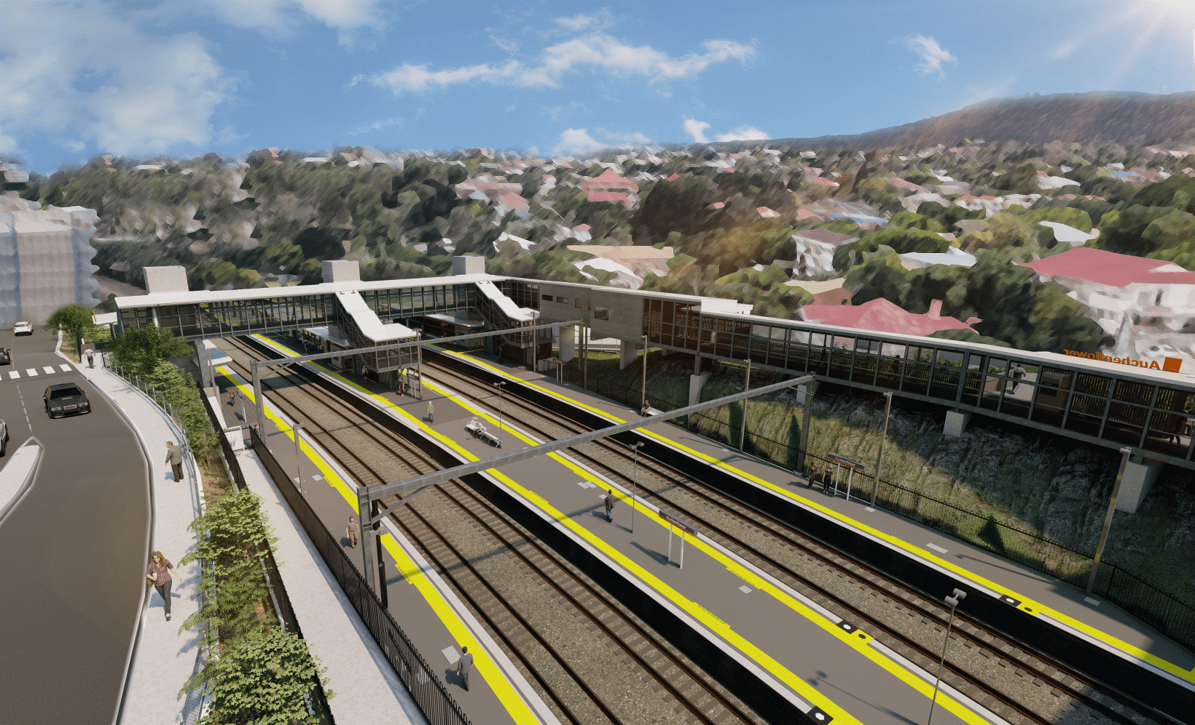

**Auchenflower station accessibility upgrade**

**WORKS NOTICE**

**Night works – platform activities**

**Monday 17 October 2022, 2am to 4am**

In preparation for upcoming station accessibility upgrade works, Queensland Rail’s project team will be at Auchenflower station after hours on **Monday 17 October 2022, between 2am and 4am**.

Works involve setting up safety bollards and flag bunting on the platform to define the work zone in preparation for the following week’s closure of platform 4.

For safety, these works have been scheduled outside of timetabled rail services when there are no trains operating.

While there will be no powered tools or equipment in use, residents near the station may experience noise associated with the presence of personnel around the station precinct.

Every effort will be made to minimise disruption and we thank you for your patience during these activities.

Queensland Rail Limited ABN 71 132 181 090

# Overview of works (weather and construction conditions permitting)

|  |  |  |
| --- | --- | --- |
| **Location** | **Dates and hours of work** | **Type of work** |
| Auchenflower station, platform 4 | **Between 2am and 4am on Monday 17 October**  (overnight works – Sunday night/ Monday morning) | Platform activities (in preparation for the week’s works):   * setting up safety barriers, bollards and flag bunting * movement of personnel around the station precinct * portable lighting towers in use at night. |

The Auchenflower station accessibility upgrade is part of the State Government’s ongoing investment of more than $500 million to upgrade stations across the South East Queensland network, making them accessible for all customers.

For more information, please contact the project’s community team on free call **1800 722 203** or email [**stationsupgrade@qr.com.au**](mailto:stationsupgrade@qr.com.au)

Sign up for electronic notifications at **queenslandrail.com.au/EmailNotification**