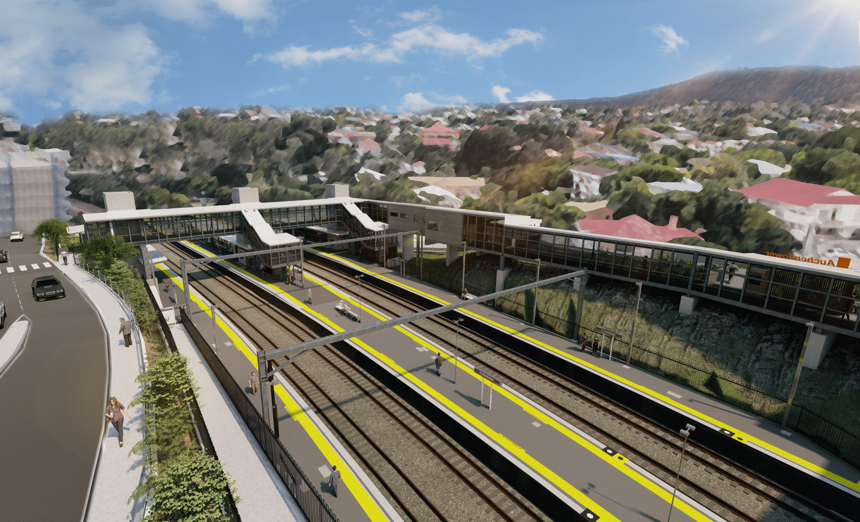

**Auchenflower station accessibility upgrade**

**WORKS NOTICE**

**Lang Parade – single lane closure**

* **Saturday 22 October 2022, 6.30am to 4pm**
* **Saturday 29 October 2022, 6.30am to 4pm**

To facilitate concrete pumping activities at Auchenflower station’s new Lang Parade entrance (near Chasely Street), a **single lane closure of** **Lang Parade**, between the hospital carpark and Chasely Street,will be in place **from 6.30am until 4pm on Saturday 22 October** and again on **Saturday 29 October.**

During these times, **exit from The Wesley Hospital carpark will be via Patrick Lane**.

Motorists are requested to drive to the changed traffic conditions and follow the instructions of the traffic controller.

We thank you for your cooperation and apologise for any inconvenience as we undertake these important works.

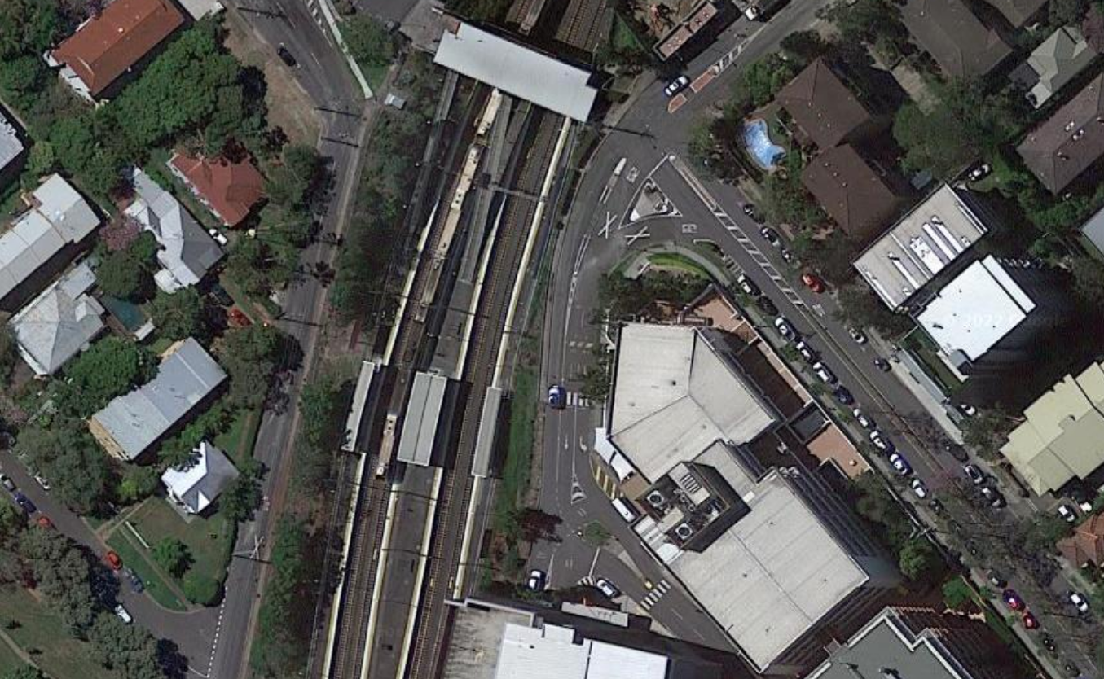

**Lang Parade**

**Chasely Street**

**STATION**

Queensland Rail Limited ABN 71 132 181 090

Lang Parade – single lane closure (exit carpark via Patrick Lane)

*Map data © Google, 2022*

**CARPARK**

The Auchenflower station accessibility upgrade is part of the State Government’s ongoing investment of more than $500 million to upgrade stations across the South East Queensland network, making them accessible for all customers.

For more information, please contact the project’s community team on free call **1800 722 203** or email [**stationsupgrade@qr.com.au**](mailto:stationsupgrade@qr.com.au)

