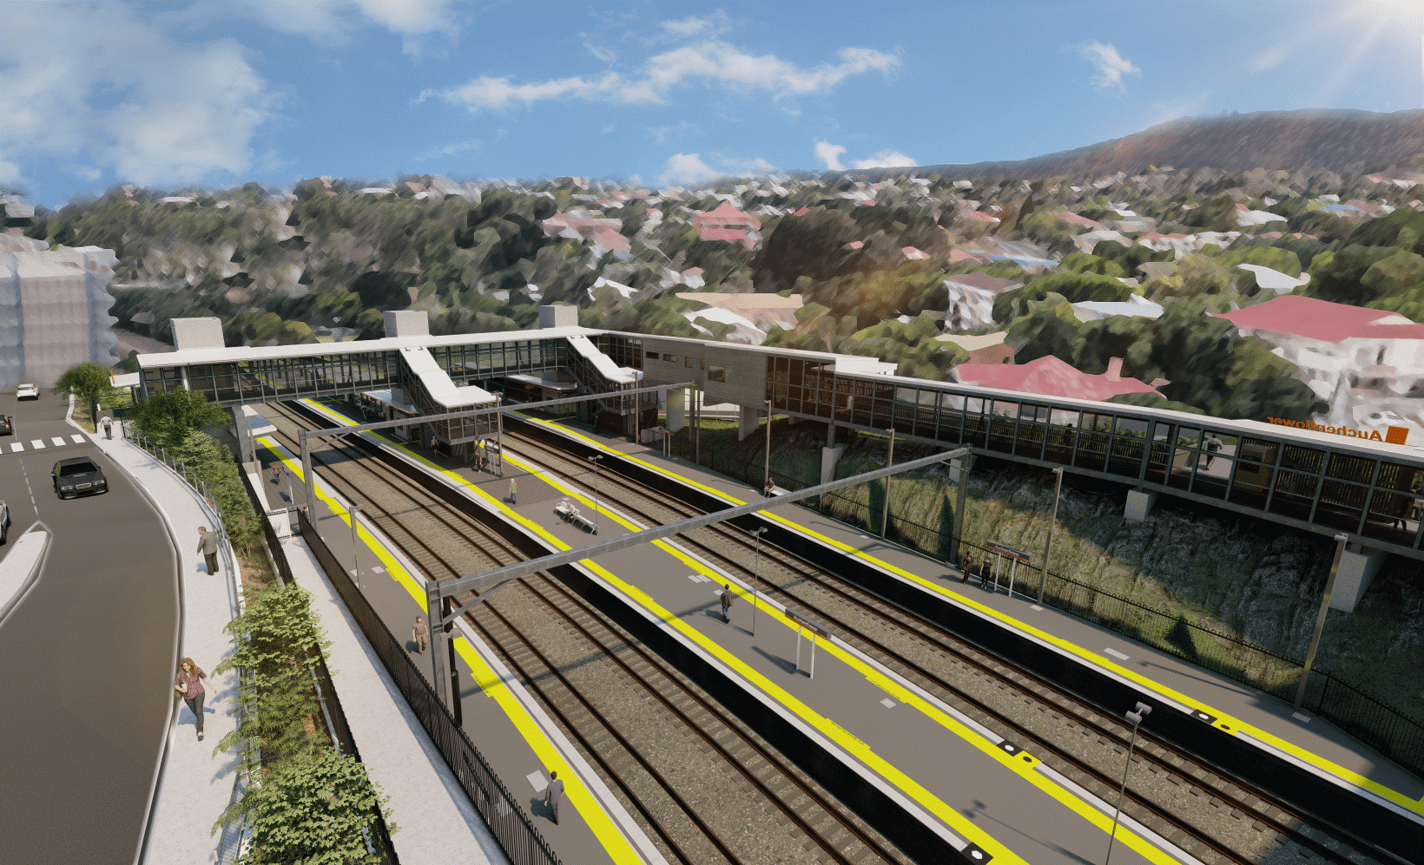

**Auchenflower station accessibility upgrade**

**WORKS NOTICE**

**Auchenflower Terrace – Full road closure**

**Extended to Friday 23 December 2022**

To support continuing construction activities for the Auchenflower station accessibility upgrade, **Auchenflower Terrace will be closed to traffic** (between McIlwraith Street and Ridley Street) until Friday 23 December 2022(weather and construction conditions permitting).

This extension to the full road closure is necessary to complete main construction activities, including concrete pours. These works represent a significant step as the project nears completion.

A traffic diversion via McIlwraith and Harriett Streets will be in operation for the duration of the road closure (see map over the page).

Access to private property will be maintained at the instruction of the traffic controller.

Motorists are requested to follow the instructions of the traffic controllers and drive to the changed traffic conditions.

Pedestrian access on Auchenflower Terrace will be maintained on the residential (or western) side of the street.

Residents near the work zone may experience noise associated with an increase in traffic along the detour route, construction activity and the operation of excavators, cranes, concrete pumping trucks and other equipment.

Every effort will be made to minimise disruption and we apologise for any inconvenience as we undertake these important works.

Night or after hours activities will be notified separately, closer to any planned works.

The Auchenflower station accessibility upgrade is part of the State Government’s ongoing investment of more than $500 million to upgrade stations across the South East Queensland network, making them accessible for all customers.

Queensland Rail Limited ABN 71 132 181 090

**For traffic management enquiries, please contact John Holland Group’s on-site representative on telephone 0409 271 836.**

For more information about the accessibility upgrade, please contact the project’s community team on free call **1800 722 203** or email [**stationsupgrade@qr.com.au**](mailto:stationsupgrade@qr.com.au)

Sign up for electronic notifications at **queenslandrail.com.au/EmailNotification**

Page 2.

**Auchenflower Terrace – Full road closure**

**Extended to Friday 23 December 2022**

Queensland Rail Limited ABN 71 132 181 090

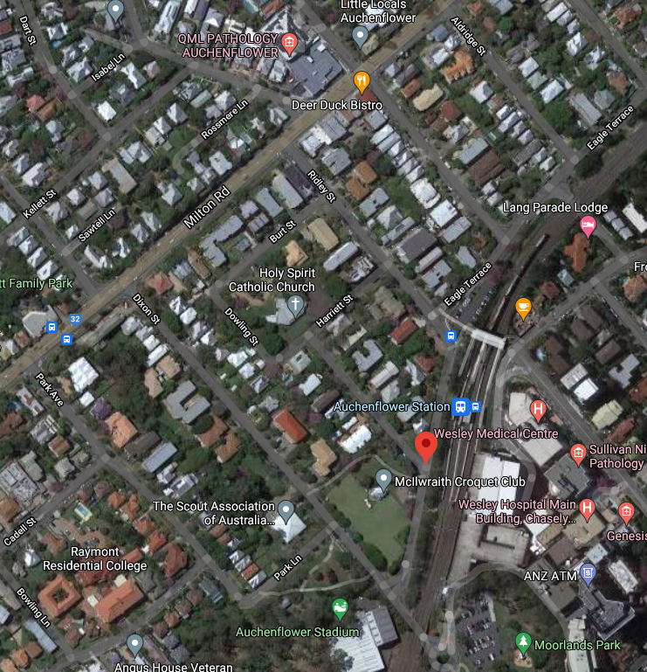

**Grimes St**

**Lang Parade**

**ROAD CLOSED TO 23 DEC**

McIlwraith St

Auchenflower Tce

Traffic diversion (via McIlwraith Street and Harriett Street)

*Map data © Google, 2022*

Road closed – Auchenflower Terrace to Friday 23 December 2022

**ROAD CLOSED**

For more information, please contact the project’s community team on free call **1800 722 203** or email [**stationsupgrade@qr.com.au**](mailto:stationsupgrade@qr.com.au)