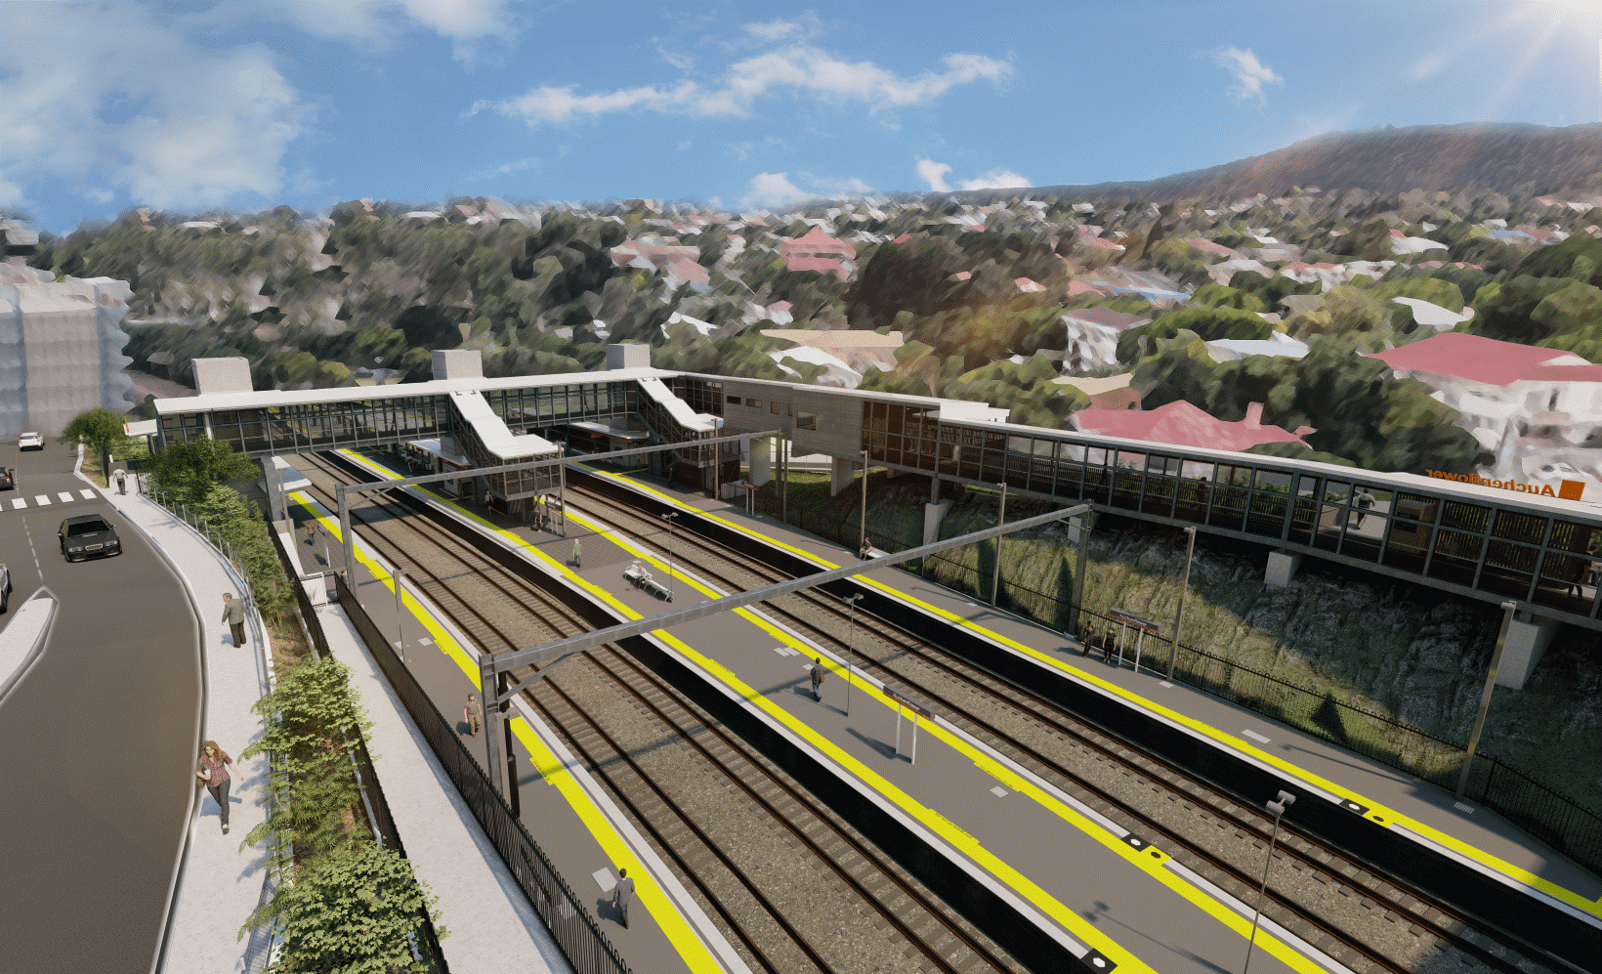

**Auchenflower station accessibility upgrade**

**WORKS NOTICE**

**Early morning works – footbridge delivery and crane establishment**

**Wednesday 20 and Friday 22 July 2022**

In addition to the night and after hours works previously notified for July, Queensland Rail will receive an early morning delivery of the new pedestrian footbridge at **approximately 4am on Wednesday 20 July**. (This is one day later than notified on the previous community works notification.)

At **approximately** **3am on Friday 22 July**, a large crane will arrive on site, in preparation for the installation of the new footbridge over the weekend track closure on Saturday 23 and Sunday 24 July.

These large vehicle movements have been scheduled after hours to minimise the impact to the local road network.

Residents near the station may experience noise associated with truck movements. Every effort will be made to minimise disruption and we thank you for your patience during these important works.

# Overview of works (weather and construction conditions permitting)

Queensland Rail Limited ABN 71 132 181 090

|  |  |  |
| --- | --- | --- |
| **Location** | **Dates and hours of work** | **Type of work** |
| Auchenflower station, carpark and rail corridor  Surrounding local streets (including Auchenflower Terrace, Ridley Street, Eagle Terrace) | *Additional after hours works in July*   * **Wednesday 20 July, from 4am** * **Friday 22 July, from 3am**     (early morning truck movements)  *NOTE: These dates are in addition to night and after hours works previously notified for July.* | Large truck movements, in preparation for the footbridge installation:   * delivery of new pedestrian footbridge by truck * arrival and establishment of large crane (for footbridge lift 23 and 24 July) * movement of vehicles with flashing lights and reversing beepers * movement of project personnel around the work zone and station precinct * portable lighting towers in use at night. |

The Auchenflower station accessibility upgrade is part of the State Government’s ongoing investment of more than $500 million to upgrade stations across the South East Queensland network, making them accessible for all customers.

For more information, please contact the project’s community team on free call **1800 722 203** or email [**stationsupgrade@qr.com.au**](mailto:stationsupgrade@qr.com.au)

Sign up for electronic notifications at **queenslandrail.com.au/EmailNotification**