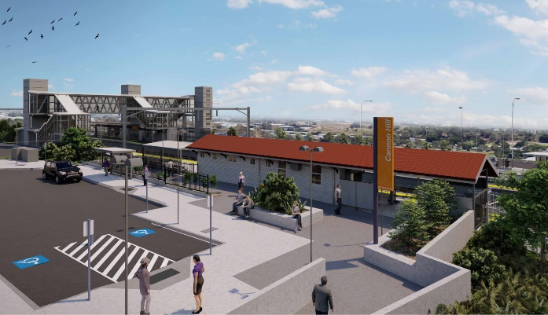

**Cannon Hill station accessibility upgrade**

**PROJECT UPDATE – MARCH 2021**

**The Cannon Hill station accessibility upgrade is part of the State Government’s ongoing investment of more than $500 million to upgrade stations across the South East Queensland network, making them accessible for all customers.**

**Project progress**

Works recently undertaken at Cannon Hill include:

* delivery and assembly of the new footbridge (pictured)
* grouting and sealing of paver surfaces on raised platform sections
* lift shaft works – retaining walls, waterproofing and drainage
* installation of in-ground services – electrical, communications and stormwater.

**Upcoming works**

In the coming weeks, the following activities will be undertaken:

* installation of new footbridge (crane lift)
* ticket window modifications
* ongoing platform works
* ongoing station design activities (off-site).

The station’s ticket window will close for works from Tuesday 6 April for approximately four weeks. During this period, station staff will be available to assist customers with ticket machine purchases.

Please take care around the work zones.

# 

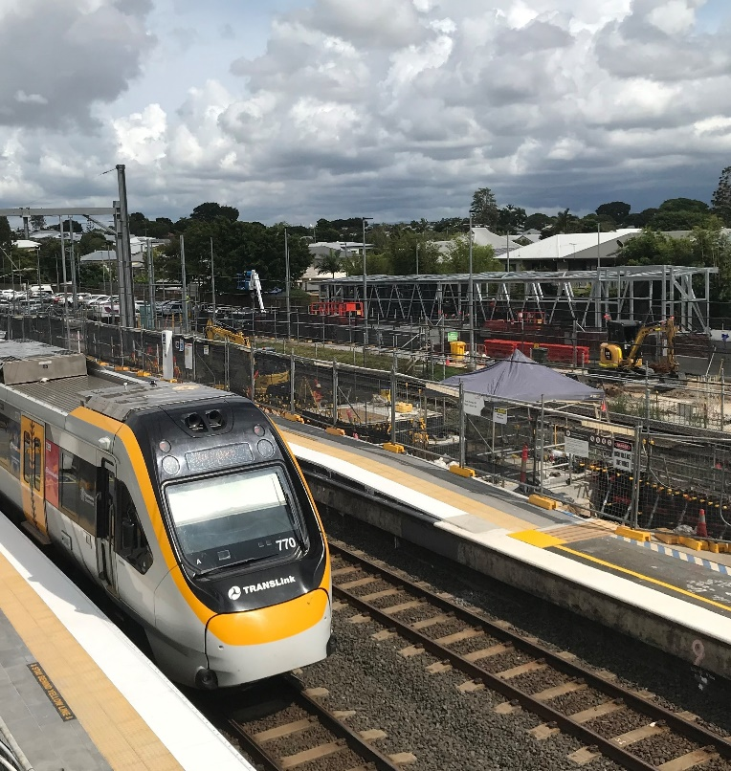

# Construction impacts

# During works, construction activities may involve:

* changed parking and traffic conditions for safety
* noise associated with heavy machinery
* temporary changes to access paths throughout the station precinct and surrounding areas
* increased vehicle movements near works
* mobile lighting towers for night works.

# Normal working hours are 6.30am to 6.30pm, Monday to Saturday.

# The local community will be given advance notification of construction activities likely to cause impacts, including after hours work (nights, Sundays and public holidays, if required).

# Thank you for your patience and cooperation as we build you a better Cannon Hill station.

# Contact us

# For more information, to provide feedback or to be added to the project’s opt-in distribution list for email updates:

# Phone: 1800 722 203 (free call)

# Email: stationsupgrade@qr.com.au

# Website: queenslandrail.com.au