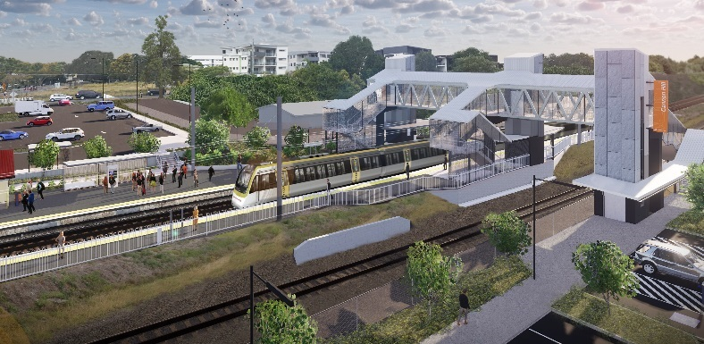

**Cannon Hill station accessibility upgrade**

**WORKS NOTICE**

**Night works – overhead line infrastructure**

**September 2019**

In preparation for the Cannon Hill station accessibility upgrade, overhead line infrastructure works will be undertaken on **Tuesday 10 and Wednesday 11 September 2019**, between **10pm and 5am** the next day (weather and construction conditions permitting).

For the safety of workers and the public, these works have been scheduled after hours, when there is reduced rail traffic.

Residents near the station may experience some noise associated with construction activity and truck movements. Mobile lighting towers will be used during night works.

Every effort will be made to minimise disruption and we apologise for any inconvenience as we undertake this concentrated period of early works.

# Scheduled night work

Queensland Rail Limited ABN 71 132 181 090

|  |  |  |
| --- | --- | --- |
| **Location** | **Dates and hours of work** | **Type of work** |
| Cannon Hill station  Adjacent rail corridor | **10pm to 5am** the next day on:   * **Tuesday 10 September** * **Wednesday 11 September**   (over 2 nights) | Overhead infrastructure works involving:   * cutting and removal of steel masts * crane operation * electrical works * operation of machinery and trucks with flashing lights and reversing beepers * hand-held tools and powered equipment * portable lighting towers at night. |

Queensland Rail’s Cannon Hill station accessibility upgrade is part of the program to upgrade stations across the South East Queensland network, making them accessible for all customers.

For more information about the accessibility upgrade, please contact the project’s community team during business hours on **1800 722 203** (free call) or email [**stationsupgrade@qr.com.au**](mailto:stationsupgrade@qr.com.au)

We are moving towards paperless notifications about noise and works. You will still see paper notices as we transition to the new system. Sign up at **queenslandrail.com.au/EmailNotification** or contact us if you prefer to receive paper copies.

